**Bycatch and extinction pressures estimated from novel tuna longline and seabird density datasets**

Authors: RM Wanless1,2, 3, R Sharma, J Rice,

1 Percy FitzPatrick Institute, University of Cape Town, Rondebosch 7701, South Africa

2 Petrichor Africa, Kampala, Uganda  
3 Previously at BirdLife International…

**ABSTRACT**

Establishing causal relationships is fundamental to scientific endeavor, with few challenges for nature as imperative today as determining drivers of extinction. Tuna longline effort has long been implicated in driving seabird extinctions, primarily from ~10 longline fleets that regularly encounter albatrosses. Species-specific, annual seabird bycatch mortality values from two novel datasets were inputted into demographic models to elucidate relationships between fisheries bycatch and the critically endangered Tristan Albatross. Results show... We encourage national and inter-governmental management authorities to develop performance metrics to evaluate progress towards achieving stated bycatch goals at both fleet level, annually, and larger scales.

INTRODUCTION

Broadly speaking, tuna Regional Fisheries Management Organisations (tRFMOs) exist to manage or change fishing activities of vessels flagged to parties to the RFMO. Managing fishing impacts on non-target taxa (bycatch) is a vexatious problem. All five tRFMOs have binding Conservation and Management Measures (CMMs) to reduce seabird bycatch during longline fishing1-5. These CMMs require, *inter alia*, data reporting and periodic reviews of effectiveness. Unverified or self-reported use of SBMMs is distinct from set-by-set data collected by national or quasi-national scientific observer programs6 or electronic monitoring (EM)7,8. Data confidentiality is a key aspect in all RFMOs – commercially sensitive and sovereign observer and EM data are managed with great care; by design and necessity the challenges to sharing confidential data are non-trivial. Some tRFMOs have undertaken these9 [others?], but they are lacking at scales larger than RFMO.

Albatrosses range exceptionally widely, with some species having circumglobal ranges in the Southern Ocean10. A rich literature exists describing the alarming, ongoing collapses of albatross (and other Procellariform seabirds) populations across the southern hemisphere11. Efforts to describe bycatch from fisheries and its likely impacts on seabirds are similarly legion12-14. A meta-analysis that summed the mean bycatch value from multiple studies to estimate global seabird bycatch from demersal and pelagic longline fishing estimated an upper value of ~300 000 seabirds killed annually12. Meta-analyses such as that cannot account for variance or methodological differences in the component studies. A statistically robust accounting of multi-fleet impacts across multiple oceans can only be done using original, raw data on observed interactions (from national scientific observer and electronic monitoring programs). The interplay between data and the rules and conditions to access them likely explains the relative paucity of credible, data-driven bycatch assessments from tuna longline fisheries beyond national settings6 – for seabirds it has only been successfully completed once15.

A global program that broadly sought to enhance the sustainability of tuna fishing was implemented through the UN Food and Agriculture Organisation (FAO), under the *Common Oceans* moniker (https://www.fao.org/in-action/commonoceans/en/). A multi-disciplinary collaboration between national data owners with confidential, scientific observer datasets, biologists with seabird bycatch expertise and statistical modellers was concluded in 2019, the aims of which were to estimate total seabird captures from tuna longline fishing across the entire southern hemisphere15. Two novel datasets were used in that project. One was a temporarily assembled dataset that combined seabird bycatch and fishing effort data from nine national programs. Access to this dataset was managed by FAO personnel, who oversaw the destruction of the only two physical copies of it at the conclusion of analyses. The second novel dataset was a

METHODS

**Metadata and descriptive statistics**

All fisheries data were drawn from confidential, sovereign sources (observer programs) or from publicly available catch-and-effort data from tRFMOs. The study area was all waters where tuna longline effort was reported from 2010-2016, south of 20°S. Observer-collected, georeferenced seabird bycatch, effort and other data for sets in the study area were accessed from Australia, Brazil, Japan, New Zealand, South Africa, South Korea, Uruguay, and data from two fleets curated by the Secretariat of the Pacific Community (n=9 fleets). These data were combined into a single, joint dataset and aggregated to 5x5° resolution. To overcome sovereign confidentiality strictures, the dataset was stored on access-controlled, external hard drives. Once analyses were concluded the dataset was destroyed through physically destroying the hard drives.

Three analytical approaches to estimating bycatch per unit effort (BPUE) were selected that account most parsimoniously for a range of data paucity/wealth scenarios, classified as either simple or complex: i) a stratified ratio estimate (SRE, simple), ii) spatially explicit generalized additive models (GAMs, complex)16 and iii) Integrated Nested Laplace Algorithm (INLA, complex)17 techniques. We explicitly compared and contrasted methods that allow catch rates to vary in space and time while accounting for different levels of information content in datasets. BPUE rates from each model were then scaled to total reported effort to generate total estimates of the numbers of seabirds caught across the study area (a 'Global C')*.* Scripts for models are publicly available at <https://github.com/seabird-risk-assessment/abnj-seabird-bycatch-analysis>.

These model formulations include a flag effect which creates a challenge of how to assign appropriately the flag effect to fleets with no observer data. Japan’s bycatch data were selected to represent unobserved fleets on the basis that this was the only available dataset with wide geographic

coverage that provided contrast in BPUE across longitude and latitude gradients. All set-level data within a trip were assumed to be independent. Additionally, the SRE approach assumes homogenous variance.

**Seabird density surfaces**

The seabird density surfaces used here are publicly accessible18. In brief, tracking datasets that were statistically representative of the population/life history stage (juvenile, non-breeding adult, etc.) were used to generate kernel densities. The monthly distribution grids for each life-history stage were multiplied by the number of individuals, calculated from stable age distribution demographic models of known numbers of breeding pairs. Those stage/class values were summed to create density surfaces at monthly and 5x5° resolution.

**Seabird Population Viability Analyses**

Population Viability Analyses (PVA) were conducted using the program VORTEX19 for select species/populations with ranges that overlapped substantially with areas of relatively good observer coverage in this study, and based on availability of demographic data. Five scenarios were modelled for each population, starting with a base case of no bycatch and four scenarios with bycatch. The sole purpose was to quantify likely demographic impacts from tuna longline bycatch, so for each scenario with bycatch we calculated Δ, the per cent difference from the base case population growth rate. Modelled demographic trends are expected to differ from observed trends, since no attempt was made to model impacts of other variables that do or likely impact vital rates. The Global C estimate (from 2016) was disaggregated into annual mortality values per species. Within each modelled population, annual mortality was further disaggregated into relative proportions of six groupings based on sex and life-history stages (i.e. juvenile, immature and adult) derived from stable age distributions. These were used as initial values and inputted as Tuna Bycatch in PVAs20 for Wandering *Diomedea exulans* (Atlantic and Indian ocean sub-populations) and Tristan *D. dabbenena* albatrosses, since their respective demographic parameters and population trends are well described21-23. Bycatch data were mostly at species resolution (i.e. there were little sex- or stage-specific data). Therefore we assumed that bycatch was proportional to age and sex in a population. Tuna Bycatch was implemented in models as a proportion i.e. the absolute annual values of the Tuna Offtake varied in proportion to the annual age- and sex-class values.

RESULTS

**Calculating Global C**

The spatial overlap between tracked seabirds and observer coverage was incomplete (Fig 5). The three modelling approaches to calculate Global C yielded broadly similar estimates (Table 2) and similar spatial distributions of seabird bycatch (Fig 6). Seabird density surface information was an important predictor of bycatch in all models. Incomplete distribution data from white-chinned petrels *Procellaria aequinoctialis*, which constitutes a high proportion of observed bycatch, was likely responsible for an underestimate of Global C. Inter-annual variation in total bycatch numbers from all models (not presented) is attributed to annual changes in both absolute effort and spatial effort distribution. The SRE approach is the least-robust estimation technique used, yet the result (~39 000 seabirds in 2016) was functionally identical to the mean of the means from all estimates (Table 2).

**GAM**

Residuals indicate a reasonably good fit for both GAM1 And GAM2 models overall. Both models indicated that the low bycatch events were best estimated and the models had poorer ability to predict high bycatch events, which is to be expected. Nevertheless, the influence of relying on a strong assumption about a fixed flag effect to predict BPUE for unobserved fleets should be noted as a source of uncertainty that could cause bias. Estimated BPUE had high variability in the first quarter of the year and those from the eastern Pacific Ocean were least reliable due to the very low observer coverage for this area (Fig 4). This precluded robust analyses of fishing impacts on seabirds from the E Pacific.

**INLA**

The choice of proxy fleets had substantive effects on INLA results, resulting in a high estimate (52,487 birds per year, CI 24,785-78,918, INLA1) when Japanese BPUE was used as a proxy. When a random effect was used for unobserved fleets, the result (33,239 birds per year, CI 22,119-45,242, INLA2) was nearly identical to the GAM and SRE estimates. We caution against assuming that closer alignment of INLA1 than INLA2 with other model results indicates greater precision from INLA1 estimates, because INLA2 likely underestimated total bycatch. The majority of observed datasets used in the estimation of the random effect are concentrated in relatively small geographical areas. In contrast, the vast spatial extent of Japanese effort makes it best representative of large geographical areas.

### Modelled bycatch impacts

The PVA base case models (i.e. no bycatch) produced credible growth trajectories for each population, and it was against these values that we evaluated bycatch impacts. The key metrics from this work are presented as changes in population growth rates (Δ) without bycatch (base case) to four scenarios with bycatch. The values for annual mortality, which were inputted as initial values for Tuna Offtake in the PVA models, are shown in Table 3. Bycatch from tuna longline fishing is currently contributing substantively towards the extinction of wandering and Tristan albatrosses (Figs 7-9). Only the lowest-bycatch scenario in the largest population (wandering albatrosses in the Indian Ocean, Fig 9) did not cause negative growth – all other scenarios show clear population decreases. Of the three populations, the Atlantic wandering albatross population’s Δ was highest due to it having the smallest starting populations (and the bycatch ‘offtake’ therefore had proportionally the biggest impact). In all cases, the actual (observed) population decreases are more severe than model results.

DISCUSSION

Every year, tuna longline fleets fishing in southern hemisphere waters accidentally catch substantive numbers of seabirds12. Bycatch and effort data from various sources provided the empirical basis for a two-step process that first estimated the numbers of seabirds killed each year, including from fleets for which observations of bycatch are unavailable, and then evaluated the resultant bycatch impacts via an annual, anthropogenic offtake from select albatross populations. Considering the means of our estimated total seabird mortality from one simple and four complex models (Table 2), annually some 32 000-40 000 seabirds die on tuna longline hooks in the southern hemisphere. The congruence between the means from three very distinct statistical approaches lends still greater confidence to this work, and affirms that the methods presented here are appropriate for future assessments along a wide data-richness spectrum. Demographic models for three *Diomedea* species/populations confirm that tuna longline bycatch is a driving factor in those species/populations’ ongoing extinction. Without substantial improvements in the performance of bycatch management by tuna longline fishing fleets and/or tRFMOs, i.e. if the status quo remains, the *Diomedea exulans* of the Atlantic Ocean and *D. dabbenena* will continue demographic trajectories towards extinction. It is highly likely that other albatross species (not modelled here due to data constraints) face similar, or worse predicaments. These results should spur all tRFMOs and the management authorities of all fleets fishing south of 25°S to strengthen efforts to reduce seabird bycatch as a high priority.

It is important to note that the most pessimistic scenario used entirely plausible, and arguably conservative estimates of true mortality. The discrepancies between modeled and observed population trends are not real discrepancies, but arise because substantial seabird bycatch occurs in other, non-tuna fisheries24. Further, the true magnitude of Illegal, Unregulated and Unreported (IUU) effort is unknown but is non-zero25, but was not accounted for in any way. It is implausible to assume that IUU fishers comply with bycatch mitigation measures and is likely to have exceptionally high bycatch rates.

The upper confidence intervals from complex models indicate that total mortality could be as high as ~57,000 (mean of UCIs) or as high as ~80,000 seabirds/year (the highest UCI from all complex models). Moreover our results are likely conservative, minimum estimates. Uncertainty from using observer data will likely be reduced only when observer coverage rates increase substantively26,27, and/or with use of cameras and electronic monitoring systems. There are multiple sources of bias that can cause substantial underestimates of true bycatch, while conversely there are relatively few, minor sources that could over-estimate bycatch (Table 5). Of the many sources of potential bias, cryptic mortality has been quantified to be double observed bycatch28. We defined it here as mortality that occurred but went undetected by an observer. It can arise from various sources, including predation or natural dislodging from lines before being retreived29, deliberate effort by crew to hide bycatch from scientific observers (for example by cutting away branchlines before a bird is hauled aboard), mis-reporting bycatch for unobserved effort, as well as other sources30. Any increase in the estimate of Global C, for example through adding previously unreported effort or quantifying (previously unreported) bycatch through electronic monitoring will result in still more negative growth trajectories.

Relevant CMMs of each tRFMO codify in various ways the duty to minimize the catch of non-target species, a duty that is also imposed through the UN Convention on the Law of the Sea. Further, the UN Food and Agriculture Organisation’s International Plan of Action recommends a target BPUE of 0.05 birds/1000 hooks31. The best estimate of BPUE from this study was 0.179 birds/1000 hooks (Table 2), more than three times the FAO-recommended target. This raises questions about the performance of tRFMOs and fleets. It is notable that bycatch data were from fleets which consistently self-report high levels of compliance with seabird bycatch CMMs. This implies that either true bycatch is under-reported or that current regulations do reduce bycatch sufficiently and should be strengthened. Best practice for seabird bycatch mitigation indicates that three measures – night setting, weighting branchlines and using a bird-scaring streamer line (or tori line) should be used simultaneously32, whereas all current tRFMO regulations mandate the use of two1-5. A management performance measure could establish a target BPUE, evaluate progress towards meeting that target, and identify where efforts could be strengthened. If we assume that compliance with using two measures is as high as self-reported data indicate, improving fisheries’ bycatch performance can take two courses. One is that additional or new measures must be implemented. This could take the form of aligning CMMs to Best Practice advice and mandate that all three measures are used simultaneously, or if fleets adopt technologies that can largely eliminate seabird bycatch33,34. A second is to enhance the practical performance of certain measures, such as bird-scaring lines. Alternatively, significant gains stand to be made if true compliance is lower than stated and can be improved.

The distribution of predicted seabird bycatch shows congruity between the various methods (Fig 6). This is likely due to three factors: the influence of the use of a global effort layer, the broad representation of input (observer) data, and the use of seabird density surfaces in all the models. Several areas of higher bycatch are apparent in Fig 6, driven by high BPUE and/or high fishing effort.

**Challenges with fishery data**

Incomplete effort data from tuna longliners operating south of 25°S will cause a proportional underestimate of bycatch. Incompleteness and/or unreliability of current tRFMO holdings of pelagic longline effort data pose significant problems for producing an accurate estimate global seabird bycatch9,24. Using the most up-to-date effort data from national sources can partially mitigate this risk. Improving the completeness and reliability of catch and effort data is a high priority for RFMOs and anyone wishing to use those data.

Blind faith in observer data is inappropriate, not least because scientific observer programs for tuna fisheries are typically designed for monitoring target species, and while other data (such as seabird interactions) may be collected systematically, they are incidental and thus not designed to achieve statistically representative proportions27. Cameras and other electronic monitoring systems can improve both the volumes and the precision of observer data, however all the data in this study were from human observers. Here we annotate a list of challenges relating to data from human observers.

1. *Reporting observer coverage:* Some programs require dedicated bycatch observations of hauling operations, whereas others record the proportion of the set observed (bycatch and other duties combined), and others consider coverage to be all effort when an observer is onboard. These approaches introduce potential biases, which become very pronounced if an incorrect assumption is made regarding what the observed effort represents14. Standardisation for how observed effort is quantified across all tRFMOs would provide self-evident benefits.
2. *Observation time bias:* Analyses using observer data typically assume that the observations are complete (all birds caught were recorded) or no systematic bias in how data were collected. This assumption fails under many plausible scenarios. For example, seldom is the entire line hauling observed; further, setting and hauling operations, and hence observations, often follow a daily routine. There is significant risk that bycatch observations are made systematically over a limited portion of the line (e.g. those portions of a longline that were set at night), and hence observers will systematically miss other sections of the line.
3. *Data not representative at trip and fleet levels:* Observer coverage is frequently biased (in space and time), particularly for seabird bycatch events. Further, coverage of the fleet may be incomplete and there may be some systematic biases in which vessels carry observers. Systematic under-observing certain segments of a fleet35 is likey to lead to underestimation of bycatch.
4. *Behaviours change when observer is/isn’t on board:* There is evidence from a diversity of sources that fleet behaviour (e.g. use of mitigation measures, areas fished, etc.) changes when observers are/are not onboard35,36.
5. *Deliberate actions to conceal seabird captures from the observer:* there are multiple ways in which crew can reduce the numbers of seabirds for an observer to record. This includes line cutting, shaking seabirds loose and positioning the observer at a point where the waters around the hauling point cannot be observed easily. Further, there may be incentives (e.g. bribes) offered to or coercion/social pressure placed on an observer to under-report seabird captures. The likelihood of the opposite is considered negligible35. These sources of bias will cause an underestimate of true bycatch of an unknown magnitude.
6. *Total interactions versus mortality, and post-release survival:* Certain observer programmes discriminate between live releases and mortalities, others only report total captures. Our seabird bycatch estimate was based on total captures. The effect of including live-released birds in total captures was ignored, since in fleets for which data exist, the proportion of live releases relative to total captures is small (unpubl. data). However, standardizing how this information is recorded and reported would remove potential biases. Further, post-release survival is unknown but unlikely to be 100%. This source of bycatch mortality counteracts to some extent the upward bias from using total captures.
7. *Species identification:* While this is a concern, it will not have any effect on estimating total seabird bycatch. Systematic bias in identification would cause problems when disaggregating.
8. *Recording use of seabird bycatch mitigation measures.* The lack of available set-by-set data on use of seabird bycatch mitigation measures means that these data are not included as factors in the current models. However, careful consideration should be given to identify key factors that determine the effectiveness of a particular mitigation measure, to improve the mandatory provision of compliance-ready data, including from independent sources such as electronic sensors and cameras8. Individual fleets and RFMOs may be unable to evaluate their performance in meeting obligations or in reducing accidental seabird mortality if this is not addressed.

The confidentiality challenges inherent in accessing and sharing sovereign fisheries data from multiple fleets have previously thwarted this sort of analysis. This was overcome by ensuring as far as possible that national scientists, in addition to contributing sovereign data, were central to the development and implementation of analytical approaches. This approach was adopted explicitly to both build analytical capacity within institutions responsible for curating sovereign observer data, and to explore methodological approaches to assessing seabird bycatch between fleets. Enhanced capacity to both monitor bycatch and regularly assess bycatch impacts is desirable, both within the fisheries administrations of parties to tRFMOs and more broadly6.

A precautionary approach should assume the worst, and act collaboratively and within existing structures to improve the performance of vessels, fleets and tRFMOs. The worst case that is borne out from this work is that tuna longline fishing is causing the extinctions of several seabird species. That said, dramatic reductions in seabird bycatch, including from longline fisheries are possible in high seas37 and domestic38,39 settings. We encourage fishing authorities and tRFMOs to develop metrics for both annual evaluations (at the fleet level) of performance in meeting a target BPUE, and periodic evaluations at tRFMO or global scales. This work also highlights the need to reconsider mandatory data submissions to tRFMOs. The provision of set-by-set, verifiable, compliance-ready data on the use/non-use of approved seabird bycatch mitigation measures will greatly improve the robustness of future impact assessments and is strongly encouraged. However the types of data, and how those data are collected and submitted, should be standardized and harmonized across tRFMOs.

REFERENCES

1 ICCAT. International Commission for the Conservation of Atlantic Tunas: report for the biennial period, 2010-2011, Part II (2011). 487 pp (ICCAT, Madrid, Spain, 2012).

2 IATTC. Inter-American Tropical Tuna Commission Compendium of active resolutions and recommendations. 178 pp (IATTC, La Jolla, California, 2019).

3 WCPFC. Conservation and Management Measures (CMMs) and Resolutions of the Western Central Pacific Fisheries Commission (WCPFC). 294 pp (Western Central Pacific Fisheries Commission Pohnpei, Federated States of Micronesia, 2022).

4 CCSBT. Report of the Twenty Eighth Annual Meeting of the Commission. 98 pp (CCSBT, Canberra, Australia, 2021).

5 IOTC. Report of the 17th session of the IOTC Working Party on Ecosystems and Bycatch. Report No. IOTC–2021–WPEB17–R[E], 90 pp (Indian Ocean Tuna Commission, 2021).

6 CCSBT. Report of the Effectiveness of Seabird Mitigation Measures Technical Group. 130 pp (Commission for the Conservation of Southern Bluefin Tuna, Tokyo, Japan, 4-6 November, 2015).

7 Brown, C. J. *et al.* Electronic monitoring for improved accountability in western Pacific tuna longline fisheries. *Marine Policy* **132**, 104664 (2021).

8 Emery, T. J., Noriega, R., Williams, A. J. & Larcombe, J. Changes in logbook reporting by commercial fishers following the implementation of electronic monitoring in Australian Commonwealth fisheries. *Marine Policy* **104**, 135-145 (2019).

9 Tuck, G. N. *et al.* An assessment of seabird–fishery interactions in the Atlantic Ocean. *ICES Journal of marine Science* **68**, 1628-1637, doi:10.1093/icesjms/fsr118

(2011).

10 Beal, M. *et al.* Global political responsibility for the conservation of albatrosses and large petrels. *Science Advances* **7**, eabd7225 (2021).

11 Croxall, J. P. *et al.* Seabird conservation status, threats and priority actions: a global assessment. *Bird Conservation International*, 1-34, doi:10.1017/S0959270912000020 (2012).

12 Anderson, O. R. J. *et al.* Global seabird bycatch in longline fisheries. *Endangered Species Research* **14**, 91-106, doi:10.3354/esr00347 (2011).

13 Clay, T. A. *et al.* A comprehensive large‐scale assessment of fisheries bycatch risk to threatened seabird populations. *Journal of Applied Ecology* (2019).

14 Rollinson, D. P., Wanless, R. M. & Ryan, P. G. Patterns and trends in seabird bycatch in the pelagic longline fishery off South Africa. *African Journal of Marine Science* **39**, 9-25, doi:10.2989/1814232X.2017.1303396 (2017).

15 Anon. Report of the Final Global Seabird Bycatch Assessment Workshop. 41 pp (Food and Agriculture Organisation, Rome, Italy, 2019).

16 Potts, S. E. & Rose, K. A. Evaluation of GLM and GAM for estimating population indices from fishery independent surveys. *Fisheries Research* **208**, 167-178 (2018).

17 Rufener, M.-C., Kinas, P. G., Nóbrega, M. F. & Oliveira, J. E. L. Bayesian spatial predictive models for data-poor fisheries. *Ecological Modelling* **348**, 125-134 (2017).

18 Carneiro, A. P. B. *et al.* A framework for mapping the distribution of seabirds by integrating tracking, demography and phenology. *Journal of Applied Ecology* **57**, 514-525 (2020).

19 Lacy, R. & Pollak, J. Vortex: a stochastic simulation of the extinction process. Version 10.0. *Chicago Zoological Society, Brookfield, Illinois, USA* (2014).

20 Finkelstein, M., Doak, D., Nakagawa, M., Sievert, P. & Klavitter, J. Assessment of demographic risk factors and management priorities: impacts on juveniles substantially affect population viability of a long‐lived seabird. *Animal Conservation* **13**, 148-156 (2010).

21 Wanless, R. M. *et al.* From both sides: dire demographic consequences of carnivorous mice and longlining for the Critically Endangered Tristan albatrosses on Gough Island. *Biological Conservation* **142**, 1710-1718, doi:DOI:10.1016/j.biocon.2009.03.008 (2009).

22 Poncet, S. *et al.* Recent trends in numbers of wandering (Diomedea exulans), black-browed (Thalassarche melanophris) and grey-headed (T. chrysostoma) albatrosses breeding at South Georgia. *Polar Biology* **40**, 1347-1358 (2017).

23 Weimerskirch, H. *et al.* Status and trends of albatrosses in the French southern territories, western Indian Ocean. *Polar Biology* **41**, 1963-1972 (2018).

24 Clay, T. A. *et al.* A comprehensive large‐scale assessment of fisheries bycatch risk to threatened seabird populations. *Journal of Applied Ecology* **56**, 1882-1893 (2019).

25 Agnew, D. J. *et al.* Estimating the worldwide extent of illegal fishing. *PLoS ONE* **4**, e4570, doi:DOI:10.1371/journal.pone.0004570.t002 (2009).

26 Curtis, K. A. & Carretta, J. V. ObsCovgTools: Assessing observer coverage needed to document and estimate rare event bycatch. *Fisheries Research* **225**, 105493 (2020).

27 Wanless, R. M. & Small, C. Considerations for designing sampling strategies in observer programs to ensure representative coverage of key variables. Report No. IOTC–2017–WPDCS13–24\_Rev1, 4 pp (Paper to the Indian Ocean Tuna Commission's Working Party on Data Collection and Statistics, Victoria, Seychelles, 26-28 November 2017, 2017).

28 Brothers, N., Duckworth, A. R., Safina, C. & Gilman, E. L. Seabird bycatch in pelagic longline fisheries is grossly underestimated when using only haul data. *PLoS One* **5**, e12491 (2010).

29 Gilman, E., Suuronen, P., Hall, M. & Kennelly, S. Causes and methods to estimate cryptic sources of fishing mortality. *Journal of Fish Biology* **83**, 766-803, doi:10.1111/jfb.12148 (2013).

30 WCPFC. Observers and corruption. Report No. WCPFC-TCC10-2014-14, 10 pp (Western and Central Pacific Fisheries Commission's Technical and Compliance Committee, Pohnpei, Federated States of Micronesia, 25-30 September, 2014).

31 Food and Agriculture Organization. *International Plan of Action for reducing incidental catch of seabirds in longline fisheries*. (FAO, 1999).

32 Wolfaardt, A., Favero, M. & Walker, N. ACAP advice for reducing the impact of pelagic longline fishing operations on seabirds. *Report to the 12th IOTC Working Party on Ecosystems and Bycatch-IOTC-2016-WPEB12-34* (2016).

33 Rodríguez, A. *et al.* Future directions in conservation research on petrels and shearwaters. *Frontiers in Marine Science* **6**, doi:10.3389/fmars.2019.00094 (2019).

34 Sullivan, B. *et al.* At‐sea trialling of the Hookpod: a ‘one‐stop’mitigation solution for seabird bycatch in pelagic longline fisheries. *Animal Conservation* **21**, 159-167 (2018).

35 Benoît, H. P. & Allard, J. Can the data from at-sea observer surveys be used to make general inferences about catch composition and discards? *Canadian Journal of Fisheries and Aquatic Sciences* **66**, 2025-2039 (2009).

36 Liggins, G., Bradley, M. & Kennelly, S. Detection of bias in observer-based estimates of retained and discarded catches from a multi species trawl fishery. *Fisheries Research* **32**, 133-147 (1997).

37 Collins, M. A. *et al.* Mitigating the impact of longline fisheries on seabirds: Lessons learned from the South Georgia Patagonian toothfish fishery (CCAMLR Subarea 48.3). *Marine Policy* **131**, 104618 (2021).

38 Petersen, S. L., Honig, M. B., Ryan, P. G. & Underhill, L. G. Seabird bycatch in the pelagic longline fishery off southern Africa. *African Journal of Marine Science* **31**, 191, doi:DOI: 10.2989/AJMS.2009.31.2.7.879 (2009).

39 Maree, B. A., Wanless, R. M., Fairweather, T., Sullivan, B. & Yates, O. Significant reductions in mortality of threatened seabirds in a South African trawl fishery. *Animal conservation* **17**, 520-529 (2014).

## 

ACKNOWLEDGEMENTS

Funding for this work was provided through component 3.2.1 of FAO’s Common Oceans (ABNJ) tuna project, implemented by BirdLife International (BLI). RS’s inputs during the data analysis stage was supported by the US National Oceanic and Atmospheric Administration as part of in-kind contributions to the Common Oceans project. TCK’s participation was funded through a David and Lucille Packard Foundation grant to BLI.

Tables

**Table 1**. Summary of data attributes of the temporarily assembled dataset reflecting total and observed surface longline fishing effort (in millions of hooks) south of 20°S

|  |  |  |  |  |  |
| --- | --- | --- | --- | --- | --- |
| Year | Total reported effort | Hooks observed | 5x5 cells with reported effort | 5x5 cells observed | 5x5 cells with observed seabird captures |
| 2012 | 258.7 | 6.8 | 260 | 80 | 37 |
| 2013 | 239.2 | 9.8 | 249 | 77 | 32 |
| 2014 | 235.3 | 10.2 | 237 | 81 | 47 |
| 2015 | 206.1 | 9.8 | 260 | 92 | 53 |
| 2016 | 218.6 | 10.2 | 241 | 85 | 48 |

**Table 2**. Estimated bycatch rates (BPUE) and total annual seabird mortality from tuna longline effort south of 20°S in 2016, with 95% confidence intervals/credible intervals (\*).

|  |  |  |  |  |  |
| --- | --- | --- | --- | --- | --- |
| Model | Mean | LCI 95% | UCI 95% | BPUE | Unobserved  Fleet Treatment |
| SRBE | 39,147 | 1,030 | 110,395 | 0.180 | Proxy fleets |
| GAM1 | 38,632 | 29,962 | 50,504 | 0.177 | JPN fleet |
| GAM2 | 32,108 | 12,460 | 53,035 | 0.147 | JPN fleet |
| INLA1 | 52,487 | 24,785 | 78,918 | 0.241 | JPN fleet |
| INLA2 | 33,239 | 22,119 | 45,242 | 0.152 | Random effect |
| Means† | 39,117 | 22,332 | 56,925 | 0.179 | NA |

†Excludes SRBE

**Table 3.** Estimated numbers of individual albatrosses killed by tuna longliners in 2016, in four scenarios. Values were used as inputs to demographic models for each population.

|  |  |  |  |
| --- | --- | --- | --- |
| Scenario | Tristan | Wandering -Indian Ocean | Wandering – Atlantic Ocean |
| 1 | 238 | 220 | 54 |
| 2 | 476 | 440 | 108 |
| 3 | 395 | 399 | 98 |
| 4 | 790 | 798 | 196 |

**Table 4.** Trends in annual population changes (as a percentage) for modeled albatross populations, derived from Population Viability Analyses. Actual = published population growth rate (or range) which includes any bycatch, Base case = zero bycatch, S = Scenario, S1 = bycatch numbers estimated using a “fleet average” bycatch rate, S2 = bycatch values in S1 + cryptic mortality, S3 = bycatch numbers estimated using flag-specific bycatch rates, and S4 = bycatch values in S3 + cryptic mortality. Δ = rate of change relative to base case

|  |  |  |  |  |  |  |  |  |  |  |
| --- | --- | --- | --- | --- | --- | --- | --- | --- | --- | --- |
| Species (population) | Tristan | Δ | Wandering (Atlantic) | | Δ | | Wandering (Indian) | | Δ | |
| Observed trends | -2.8% a |  | | -1.8% b | |  | | -0.56 to 0.52%c | |  | |
| Base case | -0.91% | - | | 0.55% | | - | | 0.24% | - | | | |
| S1 | -1.60% | -0.71% | | -0.08% | | -0.63% | | 0.11% | -0.13% | | | |
| S2 | -1.86% | -0.96% | | -0.57% | | -1.02% | | -0.17% | -0.41% | | | |
| S3 | -1.76% | -0.85% | | -0.50% | | -1.45% | | -0.12% | -0.36% | | | |
| S4 | -1.97% | -1.06% | | -1.25% | | -1.80% | | -0.27% | -0.51% | | | |

aWanless et al. 2009

bPoncet et al. 2017

cWeimerskirch et al. 2018

**Table 5.** Sources of bias when estimating seabird bycatch, excluding challenges with observer datasets.

|  |  |
| --- | --- |
| Sources of bias and uncertainty | Expected impact if not accounted for |
| Use of range maps instead of seabird density surfaces | Unknown, possible overestimate |
| Not using seabird densities | Increases uncertainty |
| Incomplete seabird distribution information (stages, colonies, species, etc.) | Overestimations in data-rich areas and underestimation in data-poor areas |
| Incomplete seabird demographic information | Unknown |
| Incomplete fishing effort data | Underestimate |
| Fleets without observer data | Unknown |
| Cryptic mortality | Underestimate |
| Post-release survival | Underestimate |

|  |
| --- |
| E:\BirdlifeCPTMtg\8. Reported_BPUE\redonecoveragemapcentered.png |
| E:\BirdlifeCPTMtg\8. Reported_BPUE\lowerpanelfigure1a.png |

**Figure 1: Upper panel shows spatial distribution of total number of observed birds caught (indicated by colour) compared to distribution of observed effort (indicated by size of the blue circle, scaled by 800K hooks ), per 5x5° grid cell, for the period between 2012-2016. The lower panel indicates total pelagic longline fishing effort distribution reported by t-RFMOs in the period 2012-2016 (scaled by 5 million hooks), compared to total number of birds caught 2012-2016. Both figures are scaled to the largest circle scaled by circle area.**

**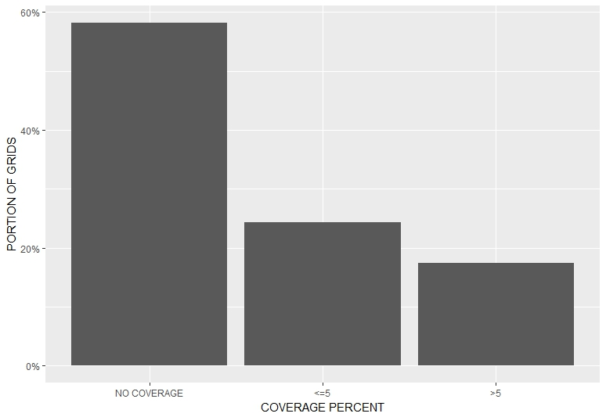**

**Figure 2: Observer Effort coverage over all oceans (number of cells meeting % observer coverage)**

**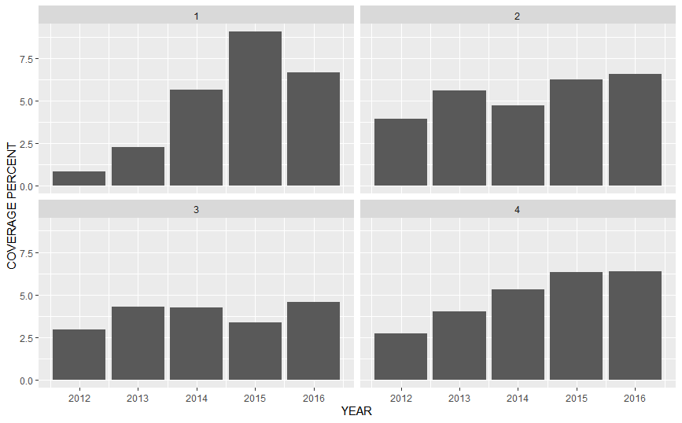**

**Figure 3: Annual observed coverage of pelagic longline fishing effort south of 20°S, by year-quarter denoted by numbered panels**

**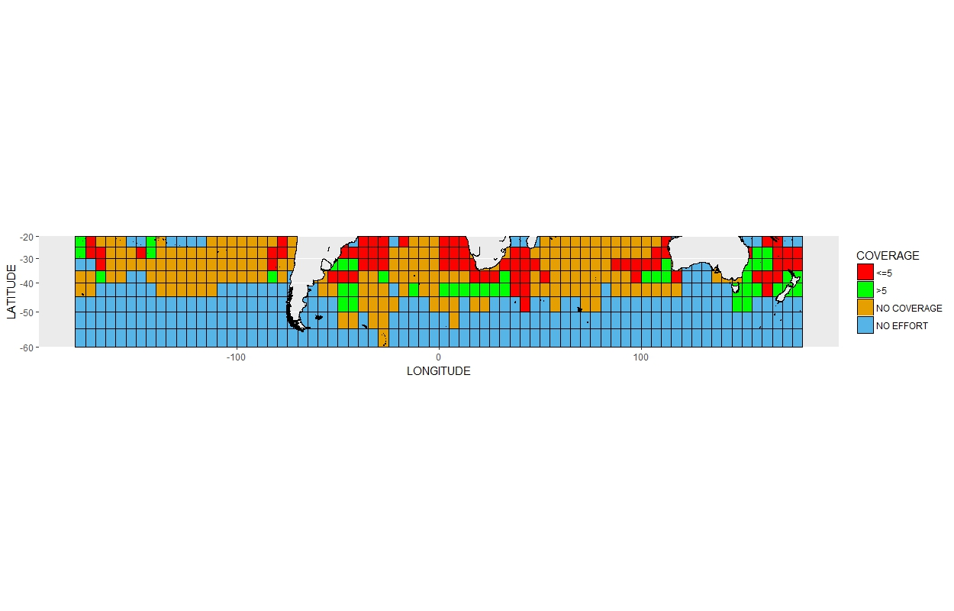Figure 4: Distribution of observer coverage rates (expressed as a percentage of total reported effort) in tuna longline fisheries operating south of 20°S (based on data from 2010-2016) at 5x5° resolution.**

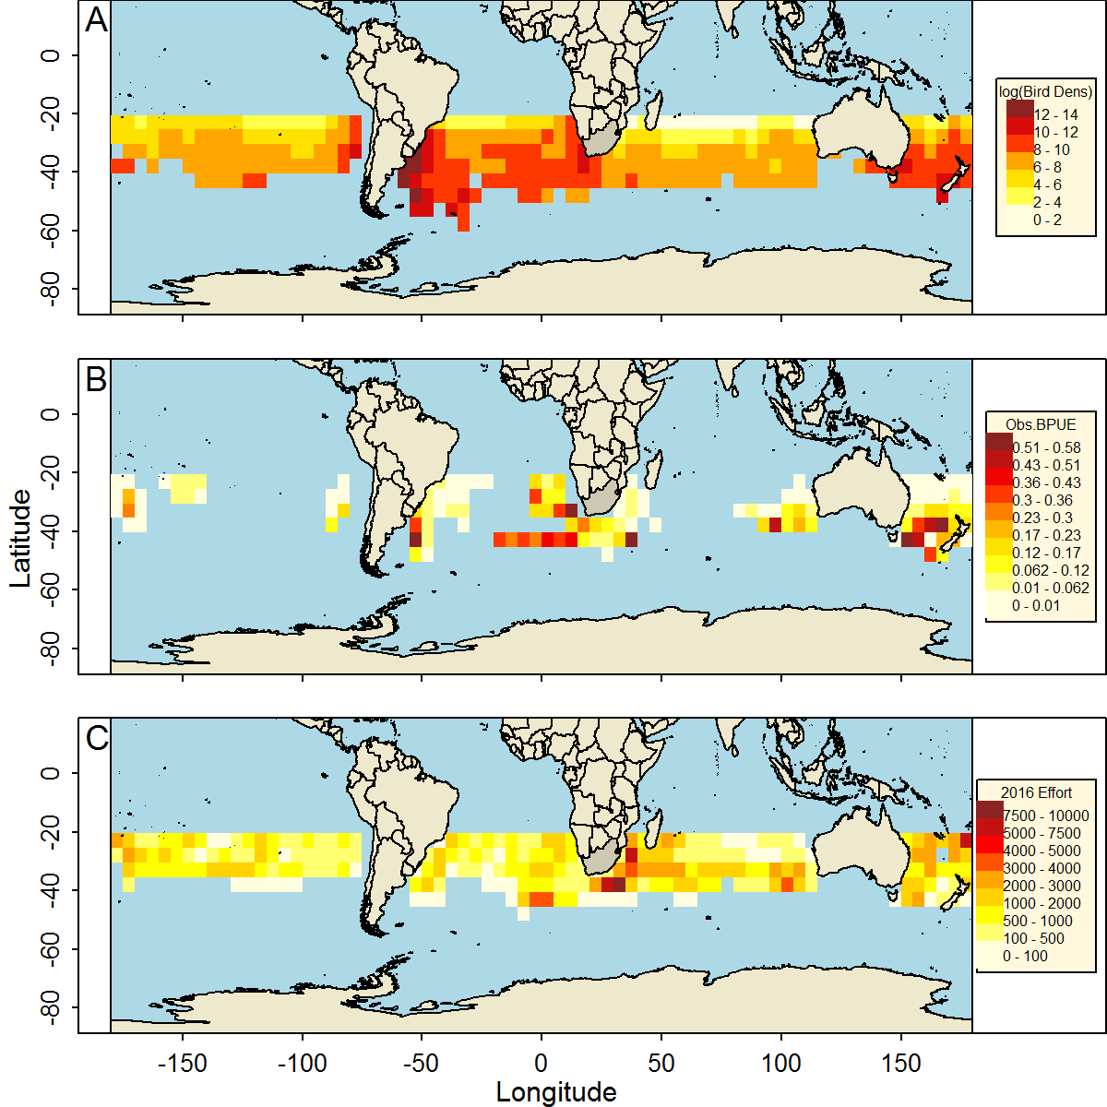

**Figure 5. Comparison of seabird density distribution with total fishing effort and observed seabird bycatch in 2016. Panels indicate seabird density surface from tracking data (A), observed seabird bycatch per 1000 hooks (BPUE) for 2016 (B) and total fishing effort by 1000 hooks for 2016 (C).**

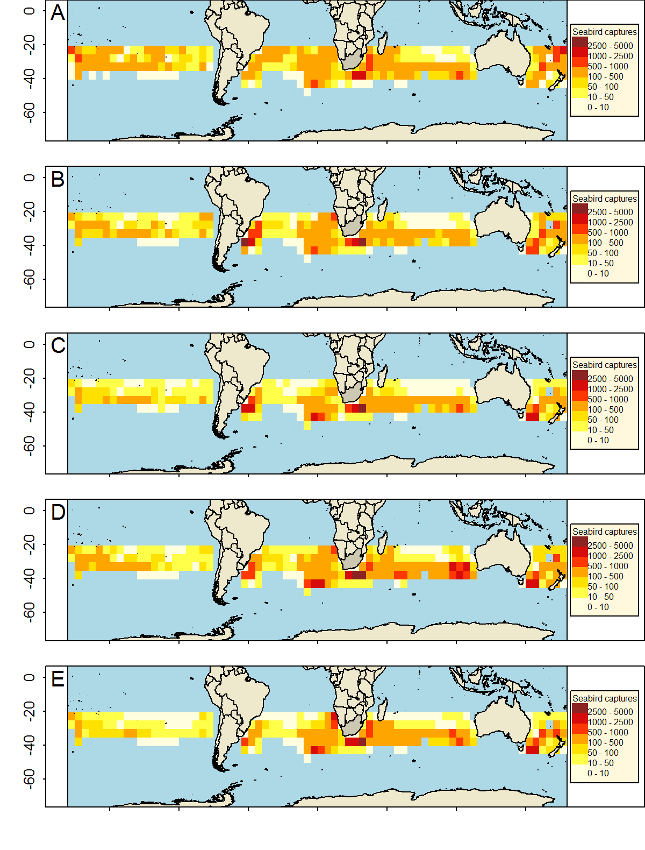

**Figure 6. Plots of estimated seabird bycatch in 2016. Panels indicate results from the ratio estimate (A), GAM1 (B), GAM2 (C), and INLA (D). Note that 5x5° squares frequently straddle international borders. Therefore cells that appear to fall within a particular EEZ may reflect effort and predicted bycatch from the portion of the cell that falls in another jurisdiction or in the high seas.**

Figure 7. Modelled breeding population of Tristan albatrosses over 50 years under five scenarios. Baseline = zero bycatch, S1 = bycatch numbers estimated using a “fleet average” bycatch rate, S2 = bycatch values in S1 + cryptic mortality, S3 = bycatch numbers estimated using flag-specific bycatch rates, and S4 = bycatch values in S3 + cryptic mortality.

Figure 8. Modelled breeding population of Wandering albatrosses at South Georgia over 50 years under five scenarios. Baseline = zero bycatch, S1 = bycatch numbers estimated using a “fleet average” bycatch rate, S2 = bycatch values in S1 + cryptic mortality, S3 = bycatch numbers estimated using flag-specific bycatch rates, and S4 = bycatch values in S3 + cryptic mortality.

Figure 9. Modelled breeding population of Wandering albatrosses at South Georgia over 50 years under five scenarios. Baseline = zero bycatch, S1 = bycatch numbers estimated using a “fleet average” bycatch rate, S2 = bycatch values in S1 + cryptic mortality, S3 = bycatch numbers estimated using flag-specific bycatch rates, and S4 = bycatch values in S3 + cryptic mortality.

**ANNEX 1 Analytical Methods.**

1. SRE

|  |  |
| --- | --- |
| Name of method | Stratified Ratio Based Estimator |
| Brief description of method | Bycatch data was estimated by fleet and ocean based on the combined dataset or literature if the stratification was missing. Associated fleets BPUE were applied to other fleets where data were not available. |
| Data input | Set-level observer data: flag; location; and, year. This was either estimated using the combined dataset produced at the Kruger meeting or through the dataset generated at the South Africa meeting or through literature based estimates. |
| Assumptions | Observed bycatch rates are representative of unsampled fleet and strata. Set-level observations within trips are independent. |
| Strengths in relation to seabird bycatch estimation | Homogenous variance across cells, and only variables explaining changes are the fleet and ocean stratification. Parsimonious and easy to implement as effort data is readily available. |
| Weaknesses/ limitations in relation to seabird bycatch estimation | Coarse scale assumptions used. I would not recommend this method over INLA or GAM or SEFRA as that estimates BPUE based on other covariates, and the data available and applies spatial structure to the missing cells. This assumes variance is homogenous across cells, and is explained by 2 variables, fleet and ocean and though parsimonious may not capture the true dynamics. |
| Impacts of input data granularity e.g. set by set or 5x5 | NA |
| Impacts of limited temporal/ spatial coverages for estimation | NA |
| Potential areas for improvement | Further stratification could occur but coverage for most fleets is limited, and literature based data doesn’t specify seasonality in most cases. Hence a coarse annual scale estimation was used. At the very least, stratifying by quarter and breeding season would be useful to include. |

### Generalized Additive Models (GAM)

Variations of these and other models treating fishery and flag as random effects were also examined, but these models did not converge.

These model formulations include a flag effect which creates a challenge of how to appropriately assign the flag-effect to fleets with no observer data. Japan’s bycatch data were selected to represent unobserved fleets on the basis that this was the only available dataset with wide geographic coverage that provided contrast in BPUE across longitude and latitude gradients. Residuals indicate a reasonably good fit for both models overall. Both models indicated that the low bycatch events were best estimated and the models had poorer ability to predict high bycatch events, which is to be expected. Nevertheless, the influence of relying on a strong assumption about a fixed flag effect to predict BPUE for unobserved fleets was noted to be a source of uncertainty can cause bias. Estimated BPUE had high variability within year-quarter 1.

|  |  |
| --- | --- |
| Name of method | Generalized Additive Models (GAM) |
| Brief description of method | The bycatch rate model was fitted to aggregated dataset distributed between 20° and 60° S, across all oceans. The data set was aggregated per 5° by 5°, season, year, quarter, and fleet flag. Tweedie errors were assumed, with a log link function. The response variable was the observed seabird bycatch rate (number of total seabirds caught per 1000 hooks) for that (area, season, year, and fleet) strata.  Two GAMs were fit to the data set with the following forms, with GAM 1 modelling the response variable (BPUE) as a function of density by quarter and flag, and GAM 2: modelled BPUE as a function of latitude by season plus density and flag effect. In both cases density was log transformed, and Tweedie errors were assumed.  GAM 1: BPUE ~ s(density| quarter) + flag.  GAM 2: BPUE ~ s(latitude | season) + s(density) +flag |
| Data input | Aggregated-level observer data: flag; location latitude, longitude (at 5° resolution); year; season; seabird density distribution; seabird bycatch rate (number of birds per 1000 hooks). Explanatory variables that were coded as a factor included flag; season, year, a smooth function for seabird density distribution and latitude was used. |
| Assumptions | Observed bycatch rates are representative of total bycatch rates for a given fleet operating in a location and season. The observed fleets are a good and representative sample of the seabird bycatch capacity of the non-observed fleets. |
| Strengths in relation to seabird bycatch estimation | The distinct approaches used leads to very close estimations, this pattern could provide some reliability of the results observed here. The possibility in to use the seabird density distribution was a good proxy to the explanations of seabird bycatch. |
| Weaknesses/ limitations in relation to seabird bycatch estimation | The approach relies on observer data to inform spatial and seasonal variation in bycatch, so bycatch rates may be less accurate in regions with limited observer coverage. The aggregations in dataset could implies in misunderstandings of specific patterns in seabird bycatch. Using aggregated dataset, some possible influences in maximizations or minimizations effects in seabird bycatch could be lost. |
| Impacts of input data granularity e.g. set by set or 5x5 | The aggregations in dataset could implies in misunderstandings of specific patterns in seabird bycatch (daylight influences, moon illumination, mitigation measures and others). Using aggregated dataset, some possible influences in maximizations or minimizations effects over seabird bycatch probably could be lost. |
| Impacts of limited temporal/ spatial coverages for estimation | The temporal fluctuations were not applied in the models. The spatial distribution could be improved to areas that was knew that exist important fisheries and seabirds interactions and were not included in these models but were predicted to. |
| Potential areas for improvement | If data were available about the catch composition relating to the observer data set, a more detailed analysis of fleet level effects could refine the estimate. This could provide more information to the models which in turn could increase the understandings of the fleet/fishery level effects on seabird bycatch. The exercise could be repeated by ocean basin, or smaller study areas. |

### Integrated Nested Laplace Approximations (INLA)

|  |  |
| --- | --- |
| Name of method | Integrated Nested Laplace Approximations (INLA) |
| Brief description of method | The INLA is a Bayesian approach proposed to perform fast Bayesian inference in Latent Gaussian Models. The model complexity of considering spatial and spatial-temporal structures with large datasets could lead to several time of computational work, principally if was used some kind of simulations. The Integrated Nested Laplace Approximation uses numeric integration methods to get marginals distributions to posteriors and thus fixing most of the computational problems involved in complex spatial or spatial-temporal models. The bycatch rate model was fitted to aggregated dataset distributed between 20° and 60° S and extended over all oceans. The data set was aggregated per 5° by 5°, season, year and fleet flag. Negative binomial errors were assumed, with a log link function. The response variable was the number of total seabirds caught by the observed fleets and combined in one unique discrete random variable. |
| Data input | Aggregated-level observer data: flag; location (5° x 5°); year; season; seabird density distribution; number of hooks. Explanatory variables included: flag; a Besag spatial structure of order 2 between the 5° by 5° square locations; a smooth function for seabird density distribution.  Season and year were not directed used as explanatory variables in models. They were used as proxies to changes in spatial correlations. In the case the *year* variable, this variable was used as a replication of the spatial correlations between years, without any temporal correlation structure beyond them. For the variable *season*, it was used as a group variable with a temporal autoregressive structure between the seasons. |
| Assumptions | Observed bycatch rates are representative of total bycatch rates for a given fleet operating in a location and season. The observed fleets are a good and representative sample of the seabird bycatch capacity of the non-observed fleets. |
| Strengths in relation to seabird bycatch estimation | The distinct approaches used leads to very close estimations, this pattern could provide some reliability of the results observed here. The use of the seabird density distribution was a good proxy to the explanations of seabird bycatch. |
| Weaknesses/ limitations in relation to seabird bycatch estimation | The approach relies on observer data to inform spatial and seasonal variation in bycatch, so bycatch rates may be less accurate in regions with limited observer coverage. The aggregations in dataset could imply misunderstandings of specific patterns in seabird bycatch. Using aggregated datasets, some possible influences in maximizations or minimizations effects in seabird bycatch could be lost. |
| Impacts of input data granularity e.g. set by set or 5x5 | The aggregations in dataset could imply misunderstandings of specific patterns in seabird bycatch (daylight influences, moon illumination, mitigation measures and others). Using aggregated dataset, some possible influences in maximizations or minimizations of these effects on seabird bycatch probably could be lost. |
| Impacts of limited temporal/ spatial coverages for estimation | The temporal fluctuations were not applied in the models. The spatial distribution could be improved to areas that was knew that exist important fisheries and seabirds interactions and were not included in these models but were predicted to. |
| Potential areas for improvement | Set-level data could be used along with the same global effort used here. This could provide more information to the models that could be possible to maximize the understandings of the effects in seabirds bycatch. The exercise could be repeated but the models could be longitudinal segregated. |